The Components of Entrepreneurial Thought & Action®
Heidi M. Neck, Babson College

“You may have wondered why so many things seems to be harder and take longer to accomplish than you would like—and why both things seem to be increasing. We don’t have the answer in every case, but here is an explanation that probably covers the majority of situations: the way we have been taught to solve problems was designed for a different world. To deal with uncertainty today, we need a different approach.” (From Just Start, p. 3)

Entrepreneurial Thought & Action (ET&A) is a method that can be practiced to embrace and confront uncertainty rather than avoid it. It emphasizes smart action over planning. It emphasizes moving quickly from the white board to the real world. It’s a method that can be learned and should be repeated. There is no guarantee for success but the practice does offer a few powerful assurances: 1) you will act sooner even when you don’t know exactly what to do; 2) for those things you can do you will, and for those things you can’t you will try; 3) you will try more times because trying early is a low cost experiment; 4) you will fail sooner enabling better, higher quality information to be incorporated into the next iteration; and 5) you’ll likely begin experimenting with many new ideas simultaneously.

ET&A includes two fundamental logics—prediction and creation. Prediction requires thinking about and analyzing existing information in order to predict the future, and creation is most concerned with acting and collecting new data—real and relevant data—in order to create the future. The prediction logic is better suited when we can extrapolate the future from the past while the creation logic is the only choice under conditions of extreme uncertainty. Think puzzle versus quilt!

Both logics are used and both are needed but, in general, we are expert predictors because we have been honing these skills for years. We were expert creators when we were babies—a time when everything around us was a mystery and uncertain. The only way we learned as a baby was by trial and error. Traditional education, the need to find the correct answer, and the constant need for measurement and assessment has inhibited our creative nature. So, the good news is that we were born with the ability. The better news is that you can still unleash it today. The scary news is that you have no choice in today’s world. You must practice creation!

ET&A requires a specific mindset. Not only must we alter our ways of thinking in order to see the endless possibilities in the world, but we must also go a step further and intentionally create mindshifts. Where a mindset is something you have, a mindshift is something you create through action. These mindshifts are created through the practice of ET&A. The model (Figure 1) highlights the method, which involves seven components.

- Desire. To be successful at creating and building a new business, a new strategy, a new product, or anything radically new requires desire—you have to have a strong feeling of wanting to create whatever it is.

- Start with means at hand. Here you want to start with what you have rather than what you think you need. Answer the following questions: Who am I? What do I know? Whom do I know? The composite answer will help you understand your current resource based that you can use for immediate action.

- Pay only what you can afford to lose. Leaving one’s comfort zone is always perceived as risky, but risk is relative. What is considered high risk to one may not seem high risk to another; therefore, it can be quite difficult to calculate risk and use it as a valid decision-making criterion. Rather than calculate risk, think about taking action in terms of what you are willing to lose. What are you truly willing to give up in terms of money, reputation, time, and even opportunity cost? When you know what you are willing to lose in order to take an action step, there is no risk and you are in complete control.

- Enroll others in your journey. ET&A is about collaboration and co-creation rather than competition and co-option. Sharing your ideas and enrolling others in your journey will increase your resource base, expand the possibilities available, validate your idea, and expand #2 above.

- Take small action. Once #1-4 are in place, it’s time to take action. Nothing drastic…the first action is just a small start to get you going. No excuses here. You can do it.

- Build on what you learn. Assess performance of your action. Keep in mind that early action is not about “killing” your new idea; it’s about making the idea better. There is no right or wrong answer at this stage, just better. Expect and embrace setbacks and celebrate the learning.
When Thomas Watson, the founder of IBM, was asked about the key to success he responded, “Increase the rate of failure.”

- Reflect and be honest with yourself. One question always arises: How do I know when I should stop or keep going? The answer is easy. Quit only when you know longer have the desire or if you have exceeded your affordable loss. Otherwise, the real question you have to answer now is: What are you going to do next?

The method of ET&A is meant to be repeatable and escalating. As you continue to practice the method you’ll find that your affordable loss changes (usually increases) with each action. Why? Your idea receives greater validation, you have a solid and growing knowledge base, more people have joined your team, resource stocks increase, and your overall confidence in your ability to act grows exponentially. You have embraced extreme uncertainty, controlled it, and used it to help you create what others cannot.

Figure 1: The Method of ET&A
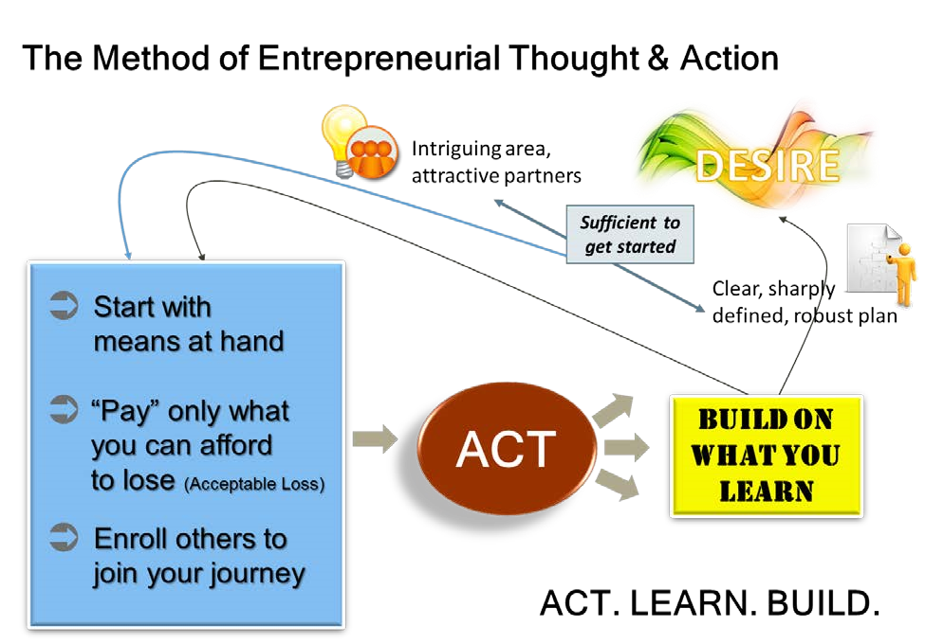

Entrepreneurial Thought & Action is a registered trademark of Babson College. Entrepreneurial Thought & Action is a methodology used at Babson College to develop entrepreneurs of all kinds. The methodology is based on the books Just Start (2012) by Len Schlesinger, Charles Kiefer, & Paul Brown, and The New Entrepreneurial Leader (2011) by Danna Greenberg, Kate McKone-Sweet, James Wilson and other Babson contributors.

